AN ASYLUM

SEEKER'S  
JOURNEY  
IN SA

Pull out infographic Pull out infographic

1

REFUGEES LEGALLY CROSS BORDER

Apply for a

6 month permit

Officials may ask for bribes

REFUGEE

RECEPTION

OFFICE (RRO)

Bribery  
Hot Spots

Enter

South

Africa

■■■■ □□□□ ■□□□ □□□□ □□□□ □□□□ ]□ □□□□

□□□□ □□□□

Seek asylum from Home Affairs official

Issued with Asylum Transit Visa

Officials  
may ask  
for bribes

REFUGEES ILLEGALLY CROSS BORDER

Renew status every 4 years

Granted

asylum

CORRUPTION WATCH

CONTACT DETAILS: www.corruptionwatch.org.zainfo@corruptionwatch.org.za

Toll free: 0800 023 456

Runners, guards and translators may ask for bribes

Interviews  
with the Refugee  
Status Determination  
Officer (RSDO)

Not satisfied with claim

Full refugee status granted  
with 5 years of uninterrupted  
years in SA

I

I

I

Full status leads to possible

Permanent Residence status

30 days to appeal to the Refugee Appeal Board

Claim is not valid

Automatically referred to the

Standing Committee for

Refugee Affairs

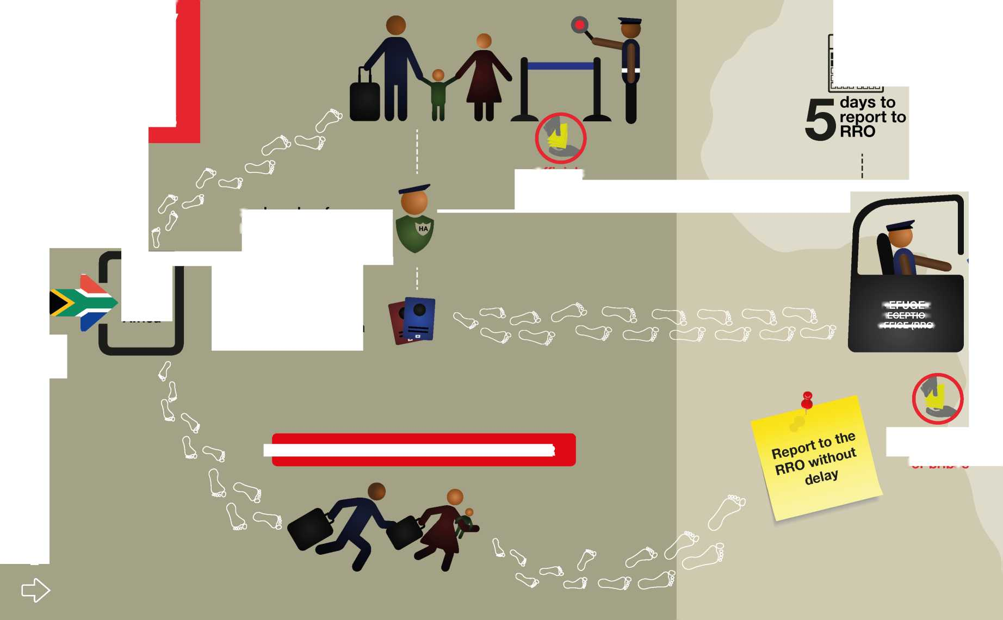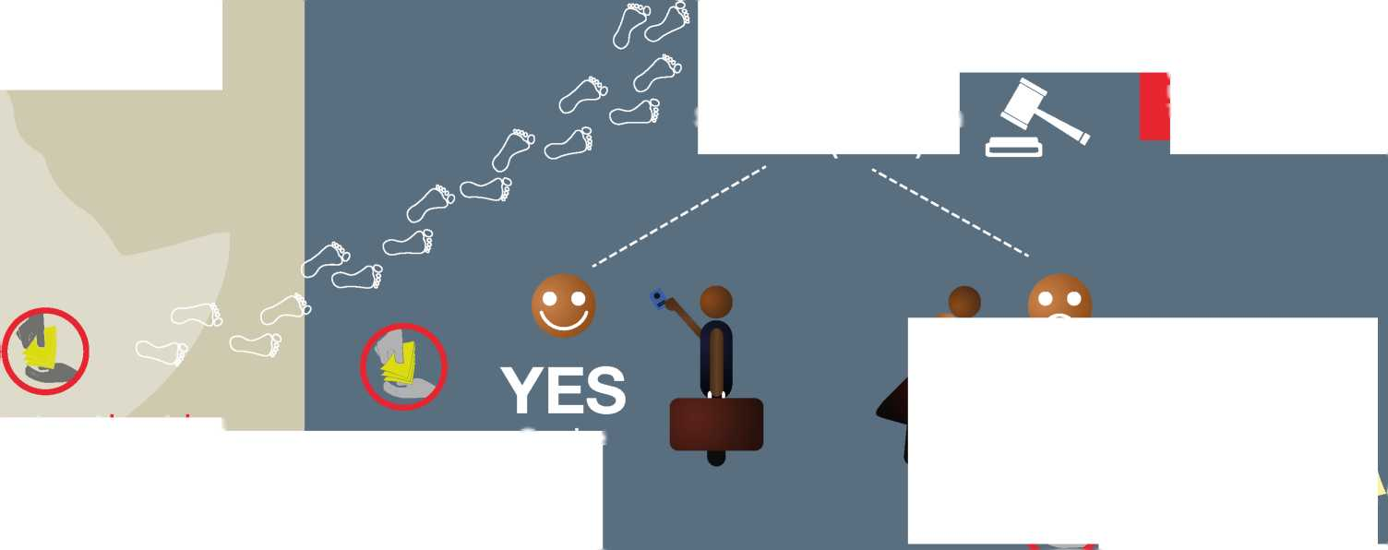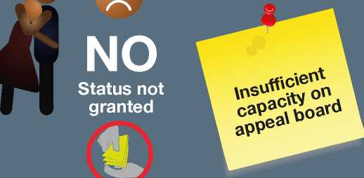

HOW THE ASYLUM SYSTEM WORKS

**South Africa has one of the most progressive and liberal asylum laws and refugee protection frameworks in the world. However, the disjuncture between law and practice has resulted in numerous points of weakness in the asylum system where corruption has been allowed to thrive.**

AT THE BORDER

A person seeking asylum may use any port of entry to enter South Africa. If an asylum seeker enters the country through an official port of entry, he or she will often declare to a border official that they intend to seek asylum in South Africa. The asylum seeker must then be issued with an asylum transit visa. This gives the person five days to report to a RRO to formally apply for asylum. However, if an asylum seeker enters the country illegally through an unofficial border post or enters clandestinely, they are protected from prosecution by the Refugees Act of 1998. If they are apprehended by a border or immigration official or a police officer they may not be detained if they indicate that they are here to seek asylum and should report “without delay” to an RRO to apply for asylum.

Weaknesses

* If the five days expire before the asylum seeker who entered South Africa legally (through a port of entry) is able to visit an RRO, the Immigration Act declares that the person becomes an “illegal foreigner” and risks arrest and deportation. This is at odds with the Refugees Act which prohibits the return of a person to a country where he or she could face persecution or threats to physical safety or freedom. It is also contrary to the 1951 UN Refugee Convention and 1969 OAU Convention, to which South Africa is a party, which recognise the right for all people to seek asylum.

**Opportunities for corruption**

* Asylum seekers have reported to the Refugee Rights Unit that they often have to pay bribes to border officials to allow them to enter South Africa, specifically at the Beitbridge Border, which was also corroborated by the 2015 study by Roni Amit, Queue Here for Corruption: Measuring Irregularities in South Africa's Asylum System, commissioned by the African Centre for Migration and Society and Lawyers for Human Rights. Some asylum seekers also informed the Refugee Rights Unit that if they inform a border official that they are here to seek asylum they are sometimes turned away. When people are turned away from the border it creates an incentive to cross the border illegally, normally with the assistance of smugglers. Moreover, it represents a serious violation of one of the key principles of international refugee law, namely that of *non-refoulement.*

REPORTING TO THE RRO

Once an asylum seeker gets into an RRO, he or she is interviewed by a refugee reception officer and given a DHA-1590 (application for asylum) form to complete. The asylum seeker's biodata and photo are captured and they are issued with an asylum seeker permit (Section 22 permit) which is valid for six months. This legalises the asylum seeker's stay, pending a final decision. The permit can be extended every four to six months during the process of status determination. The permit allows the asylum seeker to work and study in South Africa, and should protect them against deportation.

Weaknesses

* The Department of Home Affairs (DHA) has suspended all new asylum applications at the Cape Town and Port Elizabeth RROs, leaving only the Musina, Pretoria or Durban RROs open for newcomers; at the time of writing this report, Johannesburg and Tshwane interim RROs had been temporarily closed for some time.
* The RROs still accepting new applications are faced with vast queues of asylum seekers lodging new applications or extending current asylum seeker permits. The offices are often understaffed and cannot deal with the large numbers of people seeking asylum each day.
* This leads to considerable delays, backlogs and feeds corruption (when access is limited, asylum seekers will do whatever it takes to gain access to documentation and thus avoid possible detention/arrest). Even though an asylum seeker may reach a reception office within the five-day period (which was a 14-day period before the new Immigration Regulations came into effect in June 2014) this does not guarantee the actual start of the application process. Asylum seekers sometimes have to queue for several days and sleep outside the gates at night before gaining access to the building. This is worsened if an applicant misses the day allocated to his/her particular nationality, as they must then wait until the following week.

***By Popo Mfubu, attorney, Refugee Rights Unit at the University of Cape Town***

* The Refugee Rights Unit has noted that asylum seekers

are ill-informed about which offices are still open to new applications, making it even more difficult to find the right office and access it before the transit visa expires.

* The BI-1590 form is only printed in English but many asylum seekers do not have a working understanding of the language. While the refugee reception officer is required by law to help the applicant and ensure the application form is completed in full, this does not often happen in practice. The Department of Home Affairs (DHA) does make interpreters available but they are often problematic since they have been known to concoct stories for applicants as well as charge for the services that the state pays them to render. Many asylum seekers ask other asylum seekers, who have a slightly better command of English, to complete the form for them. This results in incorrect or incomplete information being captured. Sometimes refugee reception officers themselves ask other asylum seekers to help them fill in an applicant's form without checking whether they speak the same language or dialect. For example, the Swahili spoken in Burundi is different to that spoken in some parts of the Democratic Republic of Congo.
* Apart from the language barrier, some asylum seekers are illiterate and have never attended any form of formal school which makes understanding the application process and whatever form they are meant to complete even more difficult.

Opportunities for corruption

* Long queues outside the RROs result in security guards demanding money to allow access. Some officials ask for bribes directly, others send proxies to patrol the queues to solicit and accept bribes on their behalf. Once the bribe is paid, the asylum seeker is allowed inside and is assisted by the official.
* The long queues are also a symptom of a lack of capacity and human resources at the RROs. This situation lends itself to corruption because if you want to be assisted you must pay a security guard or an official.
* Some asylum seekers who have been in the application system for a long time offer new arrivals informal translation or inter­presentation services and sometimes will, after soliciting money from the asylum seeker, help fabricate claims for asylum or will add details to the new arrival's ‘'story'' in order to artificially “strengthen” their claim or “guarantee” that they get asylum.

INTERVIEWS WITH THE REFUGEE STATUS DETERMINATION OFFICER (RSDO)

Before a person's asylum seeker permit expires and in line with the next step in the status determination process, asylum seekers are expected to report to the RRO for a second interview - this time with a refugee status determination officer (RSDO). After this interview, the RSDO must issue a written decision to grant refugee status or reject the asylum application as unfounded or manifestly unfounded. When rejected as unfounded it means that the applicant has mentioned or referred to leaving their country for reasons which could afford them refugee status in terms of the Refugees Act (such as fleeing war or persecution), but the RSDO is not satisfied with the merits of such reasons or the DHA seeks further motivation for the claim. When rejected as manifestly unfounded it means that the applicant has mentioned or referred to a reason for wanting asylum that is not recognised in the Refugees Act, for example to gain employment or study in South Africa.

If an application for asylum is rejected as unfounded, the asylum seeker has 30 calendar days to lodge an appeal before the Refugee Appeal Board (RAB), a quasi independent tribunal which offers asylum seekers the opportunity to challenge the negative decision of the RSDO. The RAB then sets a date where the asylum seeker presents his or her case and an oral hearing takes place, as prescribed in law, at the office where the person initially applied for asylum.

An application can also be rejected as fraudulent or abusive if there has been misrepresentation or if there is a clear attempt to abuse the system by applying twice for asylum at different offices under different identities. These applications are automatically reviewed by the Standing Committee for Refugee SCRA.

If the RSDO rejects the application on the basis that it is manifestly unfounded, the decision is automatically referred to and reviewed by the (SCRA), which may either confirm the decision of the RSDO, set it aside and grant refugee status or refer the matter back to the RSDO for reassessment. An asylum seeker has 14 days to make written representations to the SCRA after being refused asylum on this basis.

Weaknesses

Interviews with RSDOs are often too short, with some clients reporting that they take no longer than five or 10 minutes, indicating that RSDOs do not give asylum seekers enough time to fully set out their claim.

Many asylum seekers do not have access to trained and reliable interpreters and are at the mercy of the wholly inadequate interpretation skills of other asylum seekers.

There is a tendency of RSDOs to automatically reject applications without applying their minds to the individual case before them. Written reasons produced by RSDOs have been found to be generic and, in many instances, cut and pasted reasons from other applications. The practice of rejecting all or most applications for asylum is documented in Roni Amit's 2012 study for the African Centre for Migration and Society, All Roads Lead to Rejection: Persistent Bias and Incapacity in South African Refugee Status Determination, as well as in Amit's 2010 study Protection and Pragmatism: Addressing Administrative Failures in South Africa's Refugee Status Determination Decisions.

RSDOs need to conduct a set number of interviews per day (usually 10). When asylum is rejected, there is no need for an RSDO to consult with a supervisor. However, if refugee status is granted an operations manager must sign off.

The daily quotas coupled with the duty to motivate and get sign-off when refugee status is granted places greater pressure (or incentive) on RSDOs to reject asylum applications and causes a bottleneck at the review and appeal stage where it has been found that individuals do not apply their minds either and simply rubber stamp the initial decision of the RSDO.

Furthermore, the country of origin information compiled by the DHA which is used by RSDOs to evaluate the conditions in a particular country and thus influences their decision is often inaccurate and biased.

Opportunities for corruption

The fate of an asylum seeker essentially lies in the hands of the RSDO. Some asylum seekers have reported that certain RSDOs solicit bribes of between R3 000 and R8 000 in order to grant refugee status. Refugee status documents which are issued to recognised refugees are valid for four years and allow the holder access to social grants. Moreover, once refugee status has been retained for an uninterrupted period of five years, the person is eligible to apply to remain a refugee indefinitely which would then allow for the application for permanent residence. This makes refugee status a valuable commodity - (ironically, it is for this reason that DHA is trying to take away the link to permanent residence and force refugees to be such forever). The backlogs in the system coupled with the propensity to reject all or most applications creates an environment where corruption thrives. Asylum seekers see bribes as the only way to be granted asylum in an application process that is stacked against them.

**ANCILLARY PROCESSES**

**Expired permits**

If an asylum seeker has been unable to renew their permit within the prescribed period stipulated on their permit then they are in violation of the Refugees Act. This offence is punishable by a period of imprisonment or the imposition of a fine of up to R2 500. An asylum seeker may however not pay a fine or be imprisoned if they can show that they have a “just cause” for failing to renew their permit. However, the Refugees Act does not define what amounts to “just cause”. The decision to refer an asylum seeker to court in order for them to be charged with an offence is left to the discretion of the RRO's immigration officials. Asylum seekers have reported to the Refugee Rights Unit that in order to avoid being referred to court to pay a fine, immigration officers solicit bribes.

VERIFICATION OF ASYLUM PERMITS OR REFUGEE STATUS DOCUMENTS

In order for an asylum seeker or refugee to apply for a bank account they need to have their asylum seeker document or refugee status document verified by Home Affairs. This is a free service. But asylum seekers have reported to the Refugee Rights Unit that officials at RROs often ask for bribes of between R100 and R200 in order to provide verification documents.

'fit*

|  |  |  |
| --- | --- | --- |
|  |  |  |